Community Connect

JOIN US !
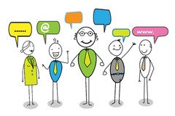

We are excited to announce the start of our second year of Community Connect family-driven local/regional meetings across the state to inform and connect families and interested parties. It is an effort that now has an electronic network of over 700 people. The goal of coming together is to explore what matters most to individuals or as family and community members involved with supporting individuals with intellectual/developmental disabilities(I/DD) and/or autism. There are many significant benefits from bringing interested parties together on the local community level and statewide.

We will be holding meetings early next year to discuss
- What makes convening worthwhile to you
- Current issues
- Your thoughts about how families can support the wonderful work of the DSPs

Stay tuned for dates, locations and times.

For more info, to start a group in your area or to add your name to the network
Contact Kim Humphrey at humphrey.phadv@gmail.com

